Problem Statement: Identify whether a string has a left recursive function or not.
Code Section:
#include<bits/stdc++.h>
using namespace std;

int main(){
int n;
cout<<"Enter the number of production rule : "<<endl;
cin>>n;
vector<string>str(n);

cout<<"enter the strings(pls avoid using white space): "<<endl;
for(int i=0;i<n;i++){
cin>>str[i];
str[i].length();

}
int j=0;

for(int i=0;i<n;i++){
for(j=0;j<str[i].length();j++){
if(j==3 && str[i][j]==str[i][0]){
cout<<str[i][0]<<"is Left recursive function"<<endl;
break;
}
else if(j!=0 && str[i][j-1]== '|' && str[i][j]==str[i][0]){
cout<<str[i][0]<<" is Left recursive function"<<endl;
break;
}
else
continue;
}

if(j==str[i].length()){
cout<<str[i][0]<<" is NOT a left recursive function"<<endl;
}
}
}
Output:
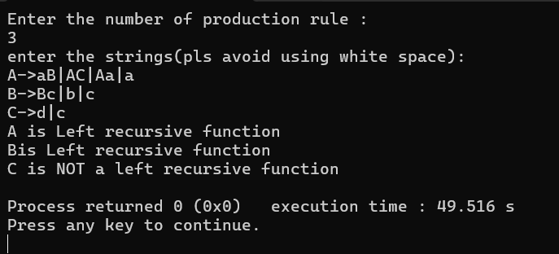

Problem Statement: Take multiple sentences to identify tokens.
Code Section:
#include<bits/stdc++.h>
using namespace std;

int main(){
int n;
cout<<"Enter the number of sentences : "<<endl;
cin>>n;
cin.ignore();

vector<string>sentences(n);
cout<<"enter the sentences: "<<endl;
for(int i=0;i<n;i++){
getline(cin,sentences[i]);
}

cout<<"tokens:"<<endl;

for(int i=0;i<n;i++){
cout<<"Sentences "<<i+1<<": "<<sentences[i]<<endl;

stringstream ss(sentences[i]);
string word;
while(ss >> word){
cout<<word<<endl;
}
}

}

Output:
